**HTTP Packet Captured using Wireshark:**

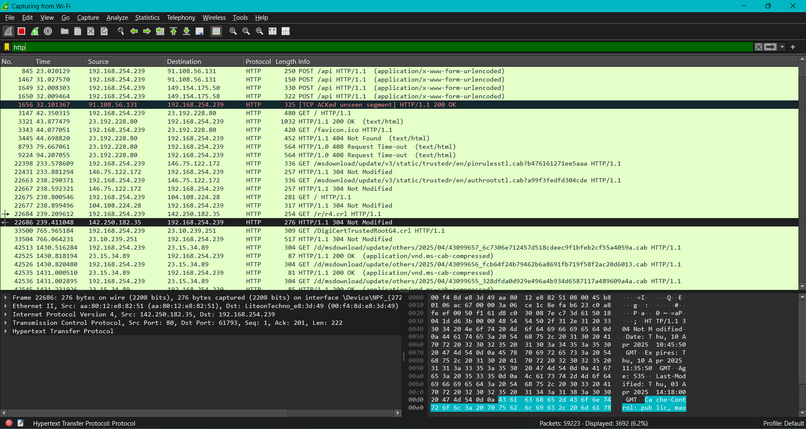

**DNS Packet Captured using Wireshark:**

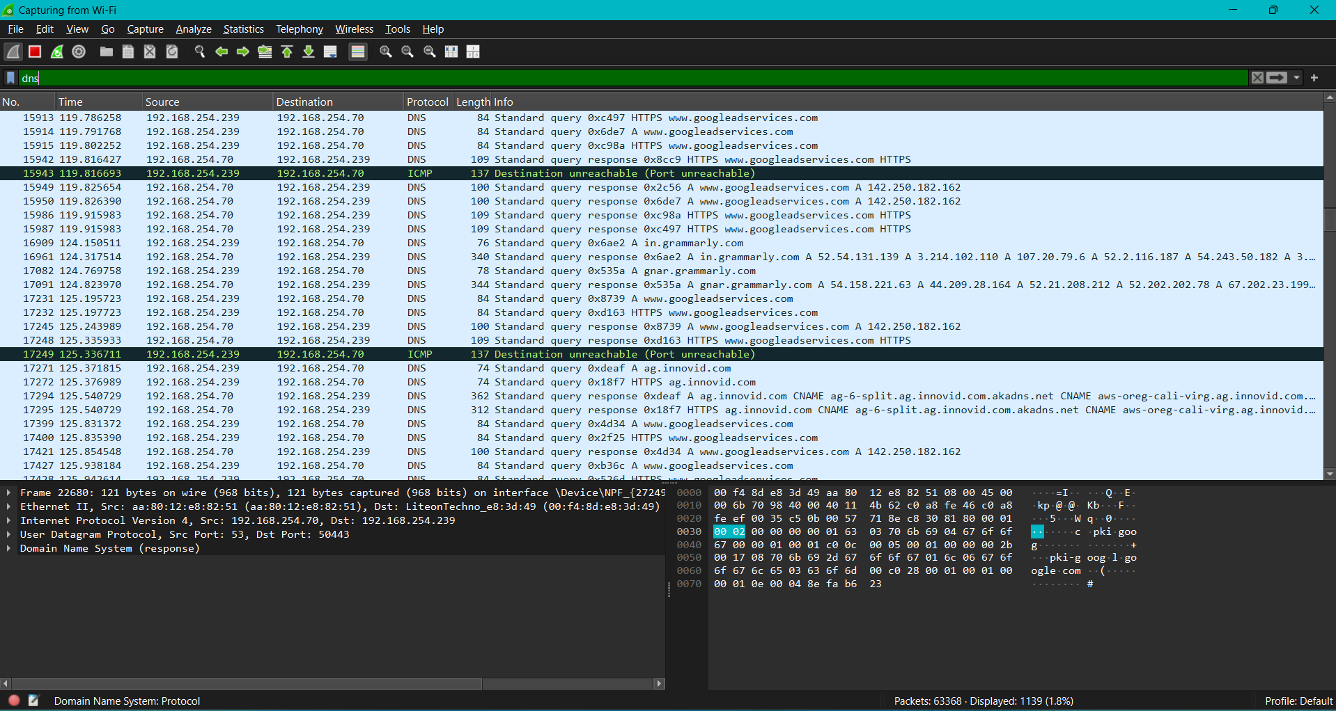

**SMTP Packet Captured using Wireshark:**

